GuideSpend AI
Architecture/Design Document

Team Members
Madhavananda Sangaraju
Siva Nikitha Mandla
Mitul Neerubai
Sai Praneeth Pothuri

Table of Contents
1 Introduction 4
2 Design Goals 4
3 System Behavior 5
3.1 Authentication Flow 5
3.2 Bank Connection Flow 5
3.3 Dashboard Interaction 5
3.4 AI Chatbot Flow 6
4 Logical View 6
4.1 High-Level Design (Architecture) 6
4.2 Mid-Level Design 7
4.3 Detailed Class Design 8
5 Process View 9
6 Development View 10
7 Physical View 11
8 Use Case View 12

Change History
Version: 3.0
Modifier: Team 8
Date: 05/01/2026
Description of Change: Final version - complete architecture documentation submitted.
______________________________________________________
Version: 2.0
Modifier: Team 8
Date: 04/10/2026
Description of Change: Updated with Plaid integration, database schema, and sequence diagrams.
______________________________________________________
Version: 1.0
Modifier: Team 8
Date: 03/20/2026
Description of Change: Initial rough draft - architecture concepts and tech stack decided.
______________________________________________________

Introduction
This document describes the architecture and design of GuideSpend AI, a secure AI-powered financial management platform developed as a capstone project (January to May 2026). GuideSpend AI enables users to connect real bank accounts via Plaid, automatically sync and track transactions, visualize spending patterns through interactive charts, and manage their finances from a single intuitive dashboard.
The purpose of this document is to describe the architecture and design of GuideSpend AI in a way that addresses the interests and concerns of all major stakeholders:
- Users and the customer: They want assurances that the architecture supports all core features including bank linking, transaction syncing, and spending analytics, while maintaining security of their financial data.
- Developers: They want a clean separation of concerns across frontend, backend, and database layers that minimizes complexity and supports independent development.
- Project Manager: The project manager needs an architecture that divides the system into well-defined modules that can be developed and tested independently. Clear API contracts between frontend and backend support parallel development.
- Maintenance Programmers: They want a system that is easy to extend. The four database tables that are already seeded but not yet wired to the frontend (budgets, fraud logs, savings, recurring transactions) represent planned future features that the architecture is already designed to support.

The architecture of GuideSpend AI is described from four perspectives:
- Logical View: Major components, their responsibilities, and how they interact with each other.
- Process View: The flow of execution across the system including request lifecycles and background processes.
- Development View: How the codebase is organized into files and modules.
- Use Case View: Key user interactions that drive and validate the design.

Design Goals
The design priorities for GuideSpend AI are as follows:
- Security first: Given that the platform handles sensitive banking credentials and financial data, all design decisions prioritize security. This includes bcrypt password hashing, JWT-based stateless authentication, Fernet symmetric encryption for Plaid access tokens, and SSL-enforced database connections.
- Separation of concerns: The system is divided into four clearly separated layers - the React frontend (presentation), the Flask REST API (business logic), AI implementation and the PostgreSQL database (persistence). Each layer communicates through well-defined interfaces.
- Minimal complexity: The entire backend is intentionally contained in a single file (app.py) to reduce the overhead of navigating multiple service files for an academic capstone project. The frontend is organized into pages and reusable components.
- Extensibility: Four database tables (budgets, fraud_logs, savings, recurring_transactions) are fully designed and seeded but not yet connected to the frontend. The architecture is designed so these features can be wired in with minimal disruption to existing code.
- Developer experience: Vite's proxy configuration eliminates issues during development. The Axios client centralizes all API call configuration including auth headers and error handling, so individual components do not need to manage these concerns.

System Behavior
The following summarizes the high-level behavior of the GuideSpend AI system from the user's perspective:

Authentication Flow
- New users navigate to /register and submit their name, email, and password.
- Returning users navigate to /login and submit their credentials.
- On successful login, a JWT token is returned and stored in localStorage. The user is redirected to /dashboard.
- On app load, AuthContext verifies the stored token via GET /protected. If invalid, the user is redirected to /login.

Bank Connection Flow
- From the dashboard, the user clicks Connect Bank Account.
- The system fetches a Plaid link token and opens the Plaid modal widget.
- The user selects their bank and enters their credentials within Plaid's secure interface.
- A temporary public token is returned to the frontend, which exchanges it for a permanent encrypted access token stored in the database.
- Transactions are synced from the linked account and the dashboard refreshes.

Dashboard Interaction
- The dashboard displays total balance, total income, and total spending as summary cards.
- Linked bank accounts are shown as BalanceCards with real-time balance data.
- Spending analytics are shown as a donut pie chart (by category) and a bar chart (by month).
- All transactions (both Plaid-synced and manual) are listed in a sortable table.
- Users can manually add transactions or delete existing ones.

AI Chatbot Flow
- The user types a financial question into the ChatBox component on the dashboard.
- The frontend sends a POST request to /chat with the user's question and JWT token.
- The Flask backend retrieves all transactions for the authenticated user from PostgreSQL.
- The transaction data is injected into a structured prompt and sent to the Gemini API.
- Gemini returns a natural language response which is displayed in the chat interface.

Logical View
The logical view describes the main functional components of the system. This includes modules, the static relationships between modules, and their dynamic patterns of interaction. In this section the modules of the system are first expressed in terms of high-level components (architecture) and progressively refined into more detailed components.

High-Level Design (Architecture)
The high-level architecture consists of 5 major components: the React Frontend, the Flask Backend API, the PostgreSQL Database (hosted on Supabase), the Plaid API for bank connectivity, and the Gemini AI API for the intelligent chatbot.

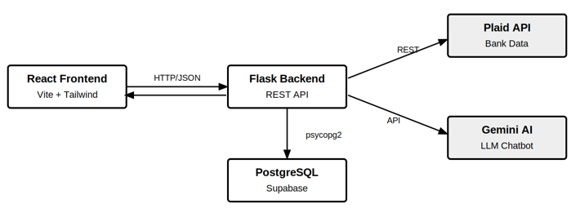
Figure 1: GuideSpend AI - High-Level System Architecture

The React Frontend serves as the presentation layer, communicating with the Flask Backend exclusively through HTTP/JSON requests via Axios. The Flask Backend acts as the central hub - it handles all business logic, authenticates requests using JWT middleware, queries the PostgreSQL database through psycopg2, calls the Plaid API for banking data, and invokes the Gemini AI API for chatbot responses. All sensitive credentials (Plaid tokens, DB passwords, API keys) are stored in environment variables and never exposed to the frontend.

Mid-Level Design
The mid-level design breaks each major component into its constituent modules and shows their relationships:

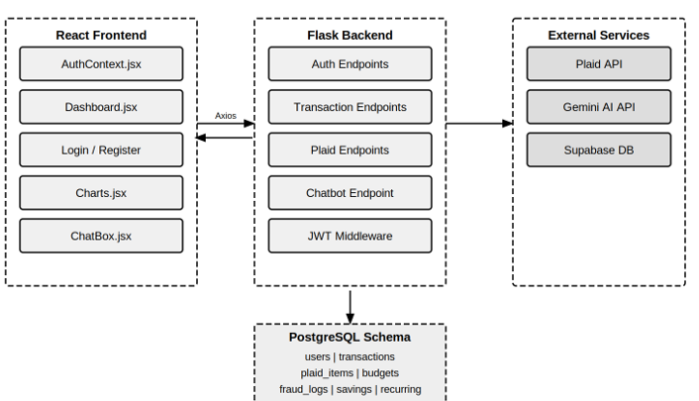
Figure 2: GuideSpend AI - Mid-Level Component Design

Detailed Class Design
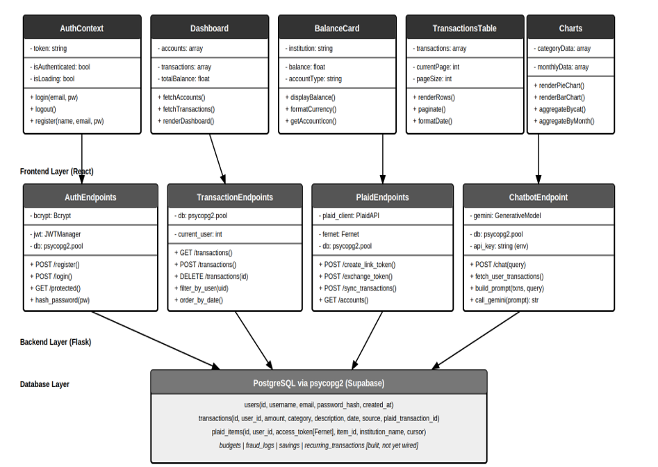

Figure 3: GuideSpend AI - Detailed Class Design

Components | Stack | Role
AuthContext | React Context API | Manages JWT token, login/logout state, token verification on app load
Dashboard.jsx | React + Axios | Fetches accounts and transactions on mount, renders all dashboard sections
Charts.jsx | Recharts | Renders donut pie chart (by category) and bar chart (monthly trend)
ChatBox.jsx | React + Axios | Sends user questions to /chat endpoint and displays AI responses
ConnectBankButton | React-Plaid-Link | Manages full Plaid Link flow from token creation to transaction sync
Auth Endpoints | Flask + bcrypt + JWT | User registration with bcrypt hashing, login with JWT issuance
Transaction Endpoints | Flask + psycopg2 | CRUD operations for manual and Plaid-synced transactions
Plaid Endpoints | Flask + plaid-python | Bank linking, token exchange (Fernet encrypted), cursor-based sync
Chatbot Endpoint | Flask + Gemini API | Fetches user transactions, builds prompt, returns AI response
PostgreSQL Schema | psycopg2 + Supabase | 7 normalized tables: users, transactions, plaid_items, budgets, fraud_logs, savings, recurring_transactions

Process View
The process view describes the sequence of operations and threads of control in the system. The following sequence diagram shows the complete flow for the two most critical processes: user authentication and bank account connection.

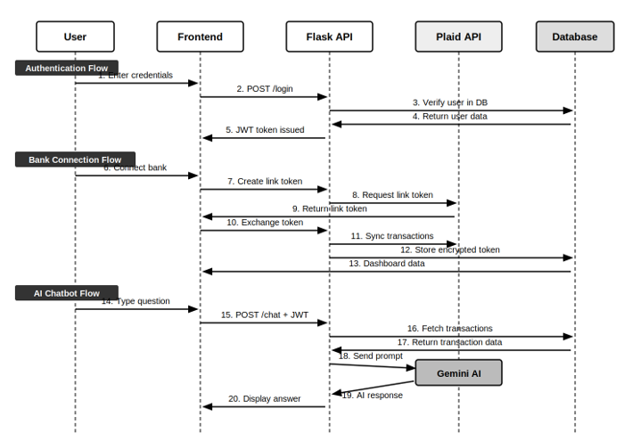

Figure 4: Bank Connection & Authentication Sequence Diagram

Key process flows in GuideSpend AI:

Authentication Process
- User submits credentials → Frontend sends POST /login → Flask verifies bcrypt hash → JWT token issued → Stored in localStorage → Axios interceptor attaches token to all subsequent requests
- On app load: AuthContext calls GET /protected → Flask validates JWT → If valid: user stays on dashboard; If invalid/expired: redirect to /login

Bank Connection Process
- POST /plaid/create_link_token → Plaid returns link token → Plaid Link widget opens → User authenticates with bank → Plaid returns public_token
- POST /plaid/exchange_token → Flask calls Plaid to exchange → access_token Fernet-encrypted → stored in plaid_items table
- POST /plaid/sync_transactions → Flask uses cursor-based sync → transactions stored with source='plaid' → Dashboard refreshes

AI Chatbot Process
- User submits question → POST /chat with JWT → Flask verifies token → Fetches all user transactions from DB → Builds structured Gemini prompt → Gemini returns response → Frontend displays answer

Development View
The development view shows how the system's source code is organized into files and modules. The project is hosted at https://github.com/MitulNeerubai/ai-banking-intelligence.

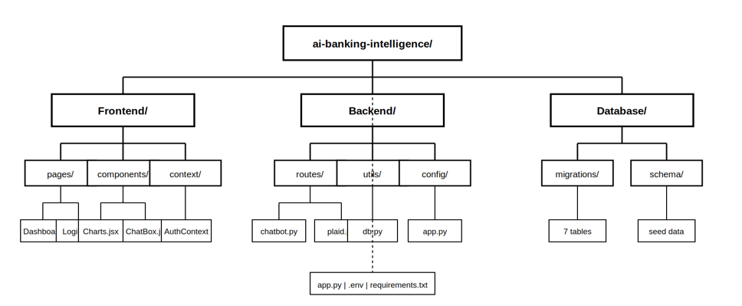

Figure 5: GuideSpend AI - Development View (File Structure)

Physical View
The physical view describes how the software components map to hardware and infrastructure. The following diagram shows the complete deployment architecture of GuideSpend AI:

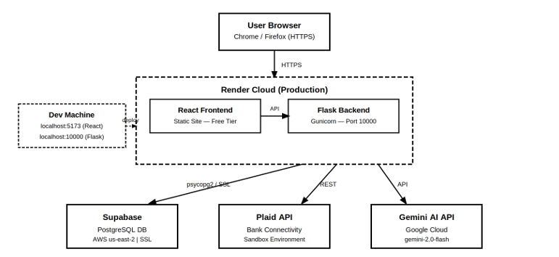

Figure 6: GuideSpend AI - Physical Deployment View

Components | Hosting | Details
React Frontend | Render (Free Tier) | Static site deployment - built with Vite
Flask Backend | Render (Free Tier) | Python web service - runs on port 10000
PostgreSQL Database | Supabase (AWS us-east-2) | Cloud-hosted PostgreSQL - SSL-enforced connections
Plaid API | Plaid Cloud | External banking data service - sandbox environment
Gemini AI API | Google Cloud | LLM service - gemini-2.0-flash model

Use Case View
The use case view validates the architecture by walking through key user scenarios and confirming that all components have the necessary behavior to execute each scenario:

Use Case 1: User Registration and Login

Steps | System Behavior
1 | User fills in name, email, password on Register page
2 | Frontend calls POST /register - Flask hashes password with bcrypt and stores user
3 | Frontend auto-calls POST /login - Flask issues JWT token
4 | JWT stored in localStorage - user redirected to /dashboard
5 | All API calls include JWT in Authorization header via Axios interceptor

Use Case 2: Connect Bank and View Transactions

Step | System Behavior
1 | User clicks 'Connect Bank Account' on dashboard
2 | POST /plaid/create_link_token - Plaid link token fetched
3 | Plaid Link widget opens - user selects bank and authenticates
4 | POST /plaid/exchange_token - access token Fernet-encrypted and stored
5 | POST /plaid/sync_transactions - transactions fetched and stored
6 | Dashboard refreshes - accounts and transactions displayed

Use Case 3: AI Chatbot Financial Query

Step | System Behavior
1 | User types 'How much did I spend on food this month?' in ChatBox
2 | Frontend sends POST /chat with question and JWT token
3 | Flask verifies JWT - fetches user's transactions from PostgreSQL
4 | Transaction data injected into structured Gemini prompt
5 | Gemini returns natural language financial analysis
6 | Response displayed in ChatBox - user receives personalized insight

